**WILKINSON GARDENS ELEMENTARY SCHOOL**





FACULTY AND STAFF HANDBOOK

**2019-2020**

**The VISION of the Richmond County School System is to create a World Class School System where all students graduate college and career ready and globally competitive.**

**The MISSION of the Richmond County School System is to build a world class school system through education, collaboration, and innovation.**

**The MOTTO of the Richmond County School System is**

**Learning Today…Leading Tomorrow**



**PURPOSE OF HANDBOOK**

The purpose of this handbook is to assist the faculty and staff of Wilkinson Gardens Elementary School in becoming aware of the policies, procedures, and other information deemed necessary for the successful operation of school. This handbook contains general information that you will need to assist you in doing a better job. It is not intended to be all inclusive, but will answer many questions that may arise, as well as make policy information readily available for you. This handbook is used to provide uniformity to our procedures. It is provided as a supplement to the Richmond County Teachers Handbook and Central Office Directives. The guidelines in this handbook are to be followed unless suspended by new guidelines.

**MISSION STATEMENT**

**The mission of Wilkinson Gardens Elementary School is to give students the tools they need to be active, lifelong learners and contributing citizens in their community and the world.**

**MOTTO**

**LEARNERS TODAY . . . LEADERS TOMORROW**

**VISION STATEMENT**

We believe. . .

• Through the shared responsibility of our Teachers, Parents, Students, and community, our students will be able to successfully compete academically and socially in a global society.

• Our students will be proficient in the use of computers to include the internet, e-mail, and word processors.

• Our students will develop Language Arts skills including reading comprehension and writing that are necessary to be on or above grade level.

• Our students will be proficient in critical thinking skills across the curriculum to include problem solving, decision making, and predicting outcomes.

• Our students will demonstrate an awareness and knowledge of Civics, Economics, History, and

Geography.

• Our students will demonstrate knowledge of scientific process skills through experience and participate in hands-on scientific learning that encompasses life, space, earth, physical, and natural science.

• Our students will demonstrate appropriate behavior in a wide variety of school and social situations.

• Our students will make responsible personal choices which demonstrate good citizenship, self-discipline, good manners, and respect for others.

• Our students will demonstrate a basic knowledge of Fine Arts to include music, theater, and visual arts.

• Our students will display good sportsmanship while gaining knowledge of a variety of competitive and individual sports.

• Our students, when engaged in everyday conversation, will be able to communicate effectively.

**CODE OF ETHICS FOR EDUCATORS**

The Code of Ethics for Educators defines the professional behavior of educators in Georgia and serves as a guide to ethical conduct. The Professional Standards Commission has adopted standards, which represent the conduct generally accepted by the education profession. The code protects the health, safety and general welfare of students and educators, ensures the citizens of Georgia a degree of accountability within the education profession, and defines unethical conduct justifying disciplinary sanction.

Standard 1: **Criminal Acts** – An educator should abide by federal, state, and local laws and statues. Unethical conduct includes but is not limited to the commission or conviction of a felony or of any crime involving moral turpitude.

Standard 2: **Abuse of Students** – An educator should always maintain a professional relationship with all students, both in and outside the classroom.

Standard 3: **Alcohol or Drugs** – An educator should refrain from the use of alcohol or illegal or unauthorized drugs during the course of professional practice.

Standard 4: **Misrepresentation or falsification** – An educator should exemplify honesty and integrity in the course of professional practice.

Standard 5: **Public Funds and Property** – An educator entrusted with public funds and property should honor that trust with a high level of honesty, accuracy, and responsibility.

Standard 6: **Improper Remunerative Conduct** – An educator should maintain integrity with students, colleagues, parents, patrons, or businesses when accepting gifts, gratuities, favors, and additional compensation.

Standard 7: **Confidential Information** – An educator should comply with state and federal laws and local school board policies relating to the confidentiality of students records, unless disclosure is required or permitted by law.

Standard 8: **Abandonment of Contract** – An educator should fulfill all of the terms and obligations detained in the contract with the local board of education or education agency for the duration of the contract.

Standard 9: **Failure to Make a Required Report** – An educator should file reports of a breach of one or more of the standards in the Code of Ethics for Educators, child abuse (O.C.G.A. 19-7-5), or any other required report as soon as possible but no later than ninety (90) days from the date the educator became aware of an alleged breach unless the law or local procedures require reporting sooner.

Standard 10: **Professional Conduct** – An educator should demonstrate conduct that follows generally recognized professional standards. Unethical conduct is any conduct that seriously impairs the certificate holder’s ability to function professionally in his or her employment position or conduct that is detrimental to the health, welfare, discipline, or morals of students (inappropriate language, physical altercations, inadequate supervision, inappropriate discipline, etc.).

The Professional Standards Commission is authorized to suspend, revoke, or deny certificates, to issue a reprimand or warning, or to monitor the educator’s conduct and performance after an investigation is held and notice and opportunity for a hearing are provided to the certificate holder. An individual whose certificate has been revoked, denied for disciplinary reasons, or suspended may not be employed as an educator, paraprofessional, aide, or substitute teacher.

“Educator” is a teacher, school or school system administrator, or other education personnel who hold a certificate issued by the Professional Standards Commission and persons who have applied for but have not yet received a certificate. For the purpose of the Code of Ethics for Educators, “educator” also refers to paraprofessionals, aides, and substitute teachers.

**Staff and Students Daily Arrival and Departure Schedule**

**Arrival**

Each faculty and staff member will be required to sign in and out each day. A daily sign-in/sign-out computer system is located in the front office. If circumstances necessitate early departure before the end of the work day, submit a certificate of absence form to an administrator and sign-out utilizing the computer system.

**Departure**

Staff badges will provide access to the building by 7:00 a.m. daily. All faculty and staff must exit the building no later than 6:00 p.m. each day. NO EXCEPTIONS unless provided prior approval from the principal.

**Tardiness**

Excessive tardiness is a detriment to the instructional program. All faculty and staff are requested and expected to be on time. Please note that failure to arrive on time may result in consequences (docked pay, written reprimand…).

* Paraprofessionals …………………………………………………………………...7:45 a.m.-3:00 p.m.
* Office Staff ……………………………………………………………………… 7:40 a.m. – 3:40 p.m.

8:15 a.m.-4:15 p.m.

* Teachers ………………………………………………………………7:45 a.m.-3:45 p.m./duty

**Custodians**

* Dunbar …………………...……………………………………………… 6:00 a.m.- 3:00 p.m.
* Leverette ………………………………………………………………… 8:00 a.m. -5:00 p.m.
* Harrison/Holmes ………………………………………………………...10:00 a.m.- 7:00 p.m.

**Students Arrival**

* Breakfast ………………………………………………………………… 7:45 a.m.-8:20 a.m.
* Tardy Bell for Students .............................................................................................. 8:20 a.m.

**Students Dismissal**

* Car Riders/Van Riders……….………..Gym/Cafeteria…….........…..…. 3:00 p.m.-3:05 p.m.
* Walkers…….………………………..2nd Grade Hallway…….……...……………….3:10 p.m.
* Buses ………………………………….Cafeteria….…………………..3:10p.m.-Upon Arrival

**WGE Arrival Procedures**

Wilkinson Gardens family,

It is our duty and responsibility to ensure that all of our students are safe. Our students must be monitored by adults at all times in order to ensure their safety. The following procedures and schedules have been put in place to ensure that we are effectively monitoring all students. Remember, it takes everyone actively pulling their weight and working as a team to ensure the overall success of the school.

**Morning Schedule and Procedures-** Staff members are required to be in place and on duty by 7:45a.m. Failure to report to duty on time will result in **letter of correction**. The letter will be placed on file at the school level.

**7:45 a.m.**

* Students will enter the building and travel to the cafeteria for breakfast, or they will travel to their grade level hallway to be seated if they desire to not partake of breakfast.
* Students who desire to eat breakfast will be directed to their designated hallway after completing breakfast.
* Students will sit crisscross applesauce on the floor in a straight line facing the direction in which they walk. Students will read their library book quietly while waiting to be released to class. Students should be reminded that the hallway is a no (0) talking zone. ​
* A teacher from each grade level must be present in the hallway **(not entering the building)** by 7:45 a.m. to ensure that students are supervised at all times.

**8:05 a.m**.

* Students will be released from the hallway to class.
* Each teacher will stand at their door and receive students by 8:05 a.m.
* All students who enter the classroom after 8:20 a.m. must have a tardy pass unless they are coming from breakfast.

**8:15 a.m**.

* All classes will watch the morning show. The teacher is responsible for making sure that it is pulled up and **ready to be viewed at 8:15 a.m**. The morning show will help to establish the culture we desire at Wilkinson Gardens. All classes must stream the show at 8:15 a.m. It is a non-negotiable. Please feel free to see Mrs. Bailey or myself with any questions or concerns that you may have. Thank you!

**8:30 a.m**.

* The Instructional day starts promptly at 8:30 a.m.

**\*\*\*Changes to Students’ mode of transportation\*\*\***

A note with a signature must be provided by the parent or guardian before a student’s mode of transportation can be changed. Verbal permission taken over the phone is NOT sufficient, nor acceptable.

***Teachers do not release students to parents from your classroom. All parents must come to the front office to sign out the child and the office will call for the student to be released.***

**PERSONAL AND PROFESSIONAL LEAVE**

Employees may take three (3) days of personal/professional leave if prior approval of the absence has been given by the employee's Principal and if the presence of the employee requesting absence is not essential for effective school operation. Personal or professional leave must be requested in writing for approval by the Principal at least two days in advance. All faculty and staff members are required to sign a certificate of absence furnished by the office. In addition, personal leave will not be granted during the first week of the student school year or during the last week of the student school year, unless the Superintendent or designee, in his or her discretion, determines that such leave should be granted due to emergency or extenuating circumstances beyond the employee's control. The Superintendent may refuse to allow an employee to take personal or professional leave if qualified substitutes are not available. Employees are not required to disclose the purpose for which such absence is sought but may be required to state whether the absence is for "personal" or "professional" reasons. Professional leave for training and/or professional meetings attended at the request of the school system shall not be counted against an employee's sick leave. The process for reporting an absence is noted on the next page.

**SICK LEAVE**

The leave provided for under this policy is available only for personal illness, injury or exposure to contagious diseases, or for absences necessitated by illness in the employee's immediate family. For the purposes of absences for medical and related reasons, members of the immediate family are defined as spouse, children, father, mother, stepfather, stepmother, sisters, brothers, grandparents, grandchildren, father-in-law, mother-in-law, or other relatives living in the home of the employee. Employees may utilize sick leave upon the approval of their principal or supervisor.

Employees absent without accumulated sick leave will have a full day's pay deducted from their salary for each day absent. For any absence in which sick leave is used, the Superintendent or his/her designee shall have the right to require a physician's certificate stating that the employee is ill and is unable to perform his or her duties. In the event that sick leave is used to care for a member of the immediate family, under the Federal Medical Leave Act an employee will be required to provide a physician's certificate stating that the employee is needed to care for the sick family member. If an employee is absent for three consecutive days of sick leave, a physician's certificate must be furnished.

All absences must be placed into the RCSS Automated Substitute System (Frontline), even if you don’t require a sub for your position. Lesson plans and activities should be available in the classroom and easily accessible for the substitute. Emergency plans must be prepared for at least 3 days and given to Mrs. Anderson. These plans will be located in the Front Office. The process for reporting an absence is noted on the next page.

**LEAVE BEFORE OR AFTER A HOLIDAY**

Any request for time off before or after a holiday must be accompanied by the approved Certificate of Absence form and a letter that specifically explains why the day off is requested. The certificate of absence must have the signed approval of Mrs. Lambert and 2 weeks in advance to the assigned Area Superintendent

for your school. A leave form must be filed and approved by the Mrs. Lambert prior to leave. Unless otherwise approved by the Superintendent or designee, personal and professional leave will not be granted during pre-planning, post-planning, in-service days or on the day before or day after holidays. The process for reporting an absence is noted on the next page.

# Staff Attendance

*** Staff attendance is **vital** to the success of the school***

**Certified Staff and Paprofessionals**

Instruction provided by classroom teachers and our paraprofessionals lend to a more quality education for our students than the instruction provided by a substitute. Consistent quality instruction will raise student achievement. Our wildcats need you every day.

**Custodians**

Custodians provide a clean, healthy, and safe work and learning environment for all staff members and students. A clean, healthy, safe learning and work environment lends for a positive climate and culture. When a member of the custodial staff is absent, the entire school is impacted. We need you every day!

**Cafeteria Staff**

Our Cafeteria staff provides a variety of nutritious meals to our students and staff in a timely manner. These meals provide the fuel for a positive work and learning environment. When a member of the cafeteria staff is absent, it hinders the effectiveness of the nutrition department. We need you every day.

**Front Office Staff**

Our front office staff plays a crucial role in ensuring that the school in functioning successfully by tending to the various needs of all other staff members, and by providing excellent customer service. When a member is absent, needs are not met in a timely manner, and customer service is not at its best. We need you every day.

Attendance and reporting to work on time is crucial for efficient and effective school operations and improving student achievement. **Chronic absences or failure to follow the proper procedures for reporting an absence will result in an unapproved absence and/or Letter of Correction.** This section is tied directly to your evaluation standard of Professionalism and will be reviewed to rate the standard.

**Reporting a Tardy**

If you are going to be late, you should call or text Mrs. Lambert on her cell phone as soon as possible. If Mrs. Lambert is unavailable, text Mrs. Bailey. The numbers are noted below.

**Reporting an Absence for Pre-Approval**

1. If you know that you must be absent: Email Mrs. Lambert and “cc” Mrs. Bailey and Mrs. Anderson requesting leave. A 48-hour notice is required for all absences. NO EXCEPTIONS! This helps to ensure that a sub is secured in a timely manner.
2. An administrator will email you back regarding whether the absence is approved.
3. Once approved, secure a sub through the *Aesop*, complete a certificate of absence form, and submit it to Mrs. Anderson **with the printed approval email from an administrator.**
4. Please remember that we do not have enough personnel to cover classes for personnel to take one, two or three hours of leave. If you have an appointment please plan on taking a half or whole day of sick or personal leave, whatever is appropriate.
5. Also please don’t wait until the day of your appointment to inform the Principal of your absence, please inform the Principal as soon as possible in advance of your planned absence.

**Reporting an Absence that has not been pre-approved (Emergency)**

If you are ill or have an emergency:

1. Call *Frontline* for a sub @ 706-826-4658 or login.frontlineeducation.com. Please secure and communicate the job number.
2. Call the Principal to report your absence @ (706) 294-1739. If the principal cannot be reached, contact the assistant principal @ (706)399-2437. Contact the school After 7:45 a.m. at 706-737-7219.
3. It is the staff member’s (teacher, paraprofessional, and cafeteria) responsibility to find a substitute. Therefore, you need to check "Aesop" to see if someone picked up. If not, you are to call off of the preferred sub list until a replacement is found.
4. Send your grade chair/team members a separate email to inform them of your absence. Inform them where important items are located, and identify students who could be classroom helpers for the substitute teacher.
5. Please be sure to see Mrs. Lambert before reporting to your classroom or department on the day that you return. If Mrs. Lambert is unavailable, please see Mrs. Bailey.

Note: ***On the 4th consecutive absence, you must provide a doctor’s note***.

**ACCIDENT REPORT**

Accident reports must be completed for any student injured at school. Reports are to be completed by the nurse and staff member responsible for supervision of students during the time of the accident. These incidents must also be reported to the Principal. Reports will be kept on file in the clinic. In the event of an emergency, illness or accident, CPR certified personnel may administer first aid ONLY. Do not make a diagnosis or give any medication of any kind – not even aspirin. Please contact the parent and provide them with details regarding accident.

**EMERGENCY PLANS**

Each teacher must develop and leave emergency plans in the event of an unscheduled absence. These plans must contain three days of instructions along with information that is necessary to assist the substitute Teacher to have a successful experience in your classroom. These plans will be given to the person designated by the Principal. Please place your plans in a folder or notebook. Please update them each nine weeks. At minimum they should include:

• A daily class schedule

• Class roll

• Emergency drill plans (tornado, fire, lockdown procedures)

• Seating chart

• Three days of lesson plans complete with activities to engage students.

Other-such as duties you may have or who should the substitute see in regards to assistance (Grade chair or the teacher next door).

**EVALUATIONS**

**Classroom Evaluations**

Classroom visitation will be made frequently by the Principal, RCSS District Administrators, RESA, Assistant Principal, and the Academic Support Specialist. Please have an observation desk in an area where we can observe your entire room, and also have a copy of your most current lesson plans available for our review. These visits are made to observe individual pupil performance and ascertain whether students are having learning or behavior problems, to observe the Teacher’s performance in the classroom, to observe various techniques and methods of instruction, to analyze the different factors affecting the teaching and learning process, and to use the results of classroom observations to improve the teaching and learning environment. These observations are to improve student achievement and Teacher effectiveness.

Informal and formative evaluations are required for each employee. These evaluations are classroom observations conducted through TKES. Observations are unannounced classroom visits which can take up to thirty minutes or longer. The observation report will be provided to the teacher within ten working days.

**Evaluation Instruments**

The Principal and Assistant Principal will share the responsibility for evaluating all certified staff in the building who are evaluated through the TKES portal and all paraprofessionals. The Principal will be solely responsible for evaluating staff members who are not evaluated through TKES with the exception of paraprofessionals. The administration team will review the evaluation tool, job description, and expectations for the current year during the preconference session at the beginning of each school year. Each staff member is responsible for ensuring that they understand expectations and are familiar with the evaluation tool that will be utilized for their Summative Evaluation. Each staff member will be responsible for providing artifacts to showcase proficiency in each area noted on Summative Evaluation tools. A copy of the components for Summative Evaluations are noted below and on the pages to follow.

**TKES Components -Orientation and Familiarization must be completed in the TKES Portal prior to the evaluation process.**

**The artifacts noted below must be uploaded as evidence in the TKES portal.**

|  |  |  |  |  |
| --- | --- | --- | --- | --- |
| **Standard 1**  Observations-no uploading necessary | **Standard 2**  Observations-no uploading necessary | **Standard 3**  Observations-no uploading necessary | **Standard 4**  Observations-no uploading necessary | **Standard 5**  Observations-no uploading necessary |
| **Standard 6**   * Data Presentations * Data Team minutes | **Standard 7**   * Observations-no uploading necessary | **Standard 8**  Observations-no uploading necessary | **Standard 9**   * Time sheet * List of contribution to school (clubs/committees) | **Standard 10**   * Contact logs * Conference forms |

A copy of the Teacher Performance Standards can be found on the next page. Further details explaining each component can be found in the TKES handbook located under the orientation tab in the TKES portal.

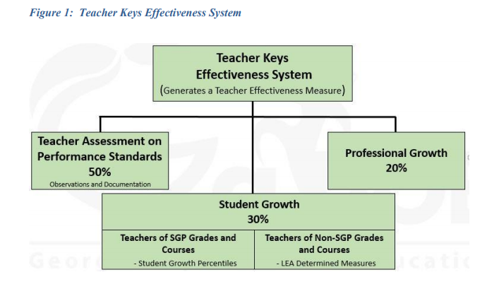

**EVALUATIONS con’t**

TKES Performance Standards (10 Standards)- Teachers must upload artifacts demonstrating proficiency for specified standards noted on the previous page. A minimum of 3 artifacts should be uploaded for the Mid-year conference. A minimum of 6 artifacts should be uploaded for specified standards for the year prior to Summative Conference. Examples of artifacts are noted in the TKES handbook, previous page, and will be provided during pre-planning.

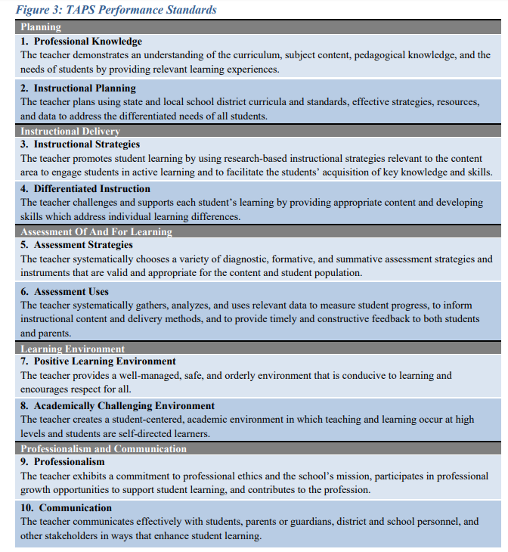

**EVALUATIONS con’t**

The evaluation tool noted on the following pages will be utilize with all staff members who are not evaluated through TKES, CKES, or Media Specialist Evaluation Tool. The employees include Data Specialist, Bookkeeper, Custodians, Cafeteria Staff, Instructional Coaches, and Paraprofessionals.

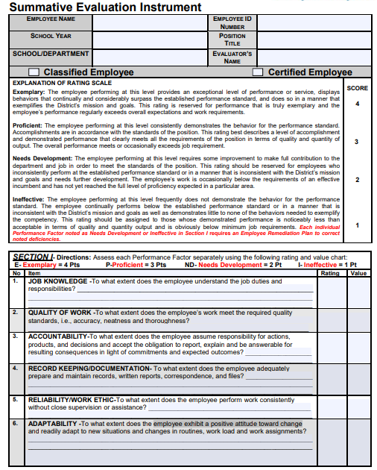

**EVALUATIONS con’t**

The evaluation tool noted on the following pages will be utilize with all staff members who are not evaluated through TKES, CKES, or Media Specialist Evaluation Tool. The employees include Data Specialist, Bookkeeper, Custodians, Cafeteria Staff, Instructional Coaches, and Paraprofessionals.

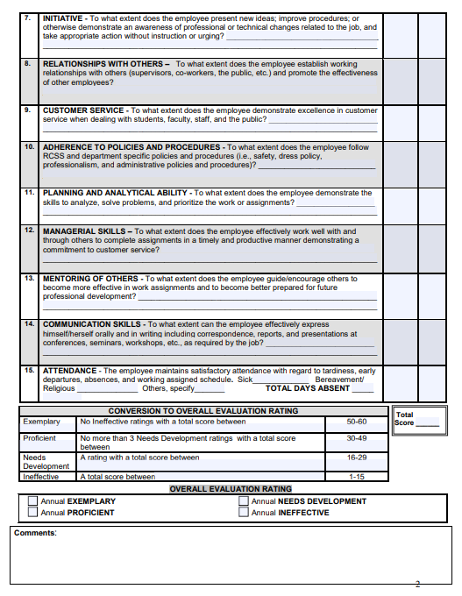

**EVALUATIONS con’t**

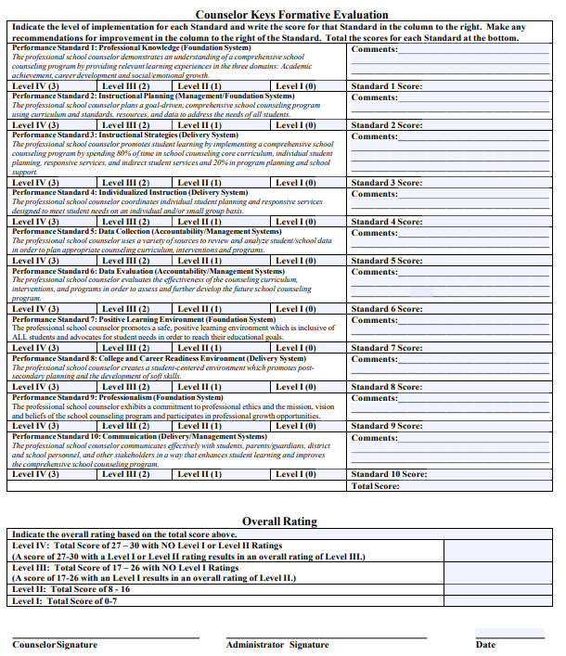

**EVALUATIONS con’t**

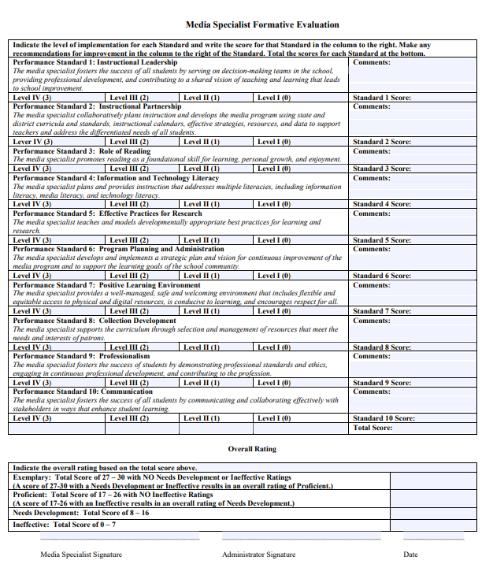

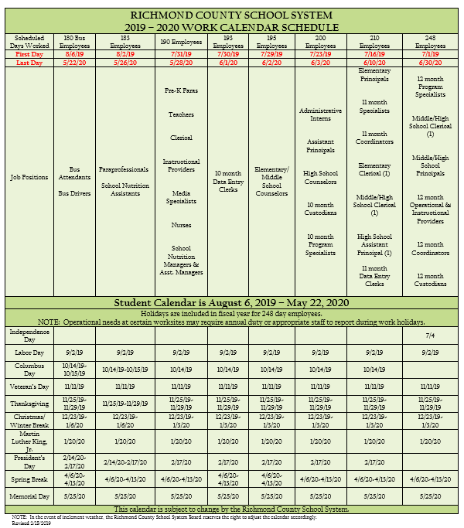

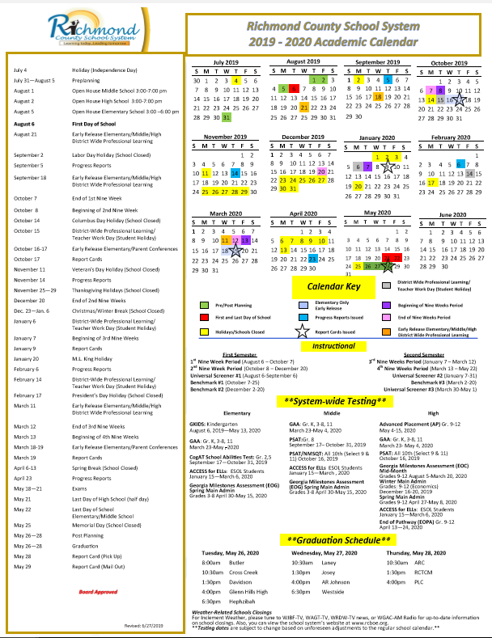

WGE Weekly Meeting Schedule

**Collaborative Planning**

Collaborative Planning sessions are provided for grade-levels to plan as a team with the Instructional Coaches during the designated schedule time (see Collab Schedule). Please use this time for the purpose intended. This is an excellent time to collaborate and plan ahead, discuss how to teach upcoming standards, and review innovative teaching materials/practices in your area(s). Collab Planning should be held in the Data Room so that student data is available for data-based planning and discussion. A collaboration schedule, collaboration minutes, and collaboration protocol guidelines are provided below. **Team collaboration is a non-negotiable.**

|  |  |
| --- | --- |
| **Grade Level Team** | |
| **Unpack** | **Standard Focus (part 1)**  Based on your pacing guide, identify a standard and annotate the standard you plan to teach. Determine what students need to know, understand, and be able to do to meet/achieve the standard. Re-read domain heading and cluster to identify connected/related standards. Identity potential student misconceptions, misunderstandings, or mistakes. Identify Academic and Domain-Specific Language (Key Vocabulary).  Refer to GADOE Guide-Rubicon Atlas-Teacher Content Development Tools folders 1 & 4 |
| **Assessment Development (part 2)**  Determine how students can show mastery by identifying quality questions, crucial skills needed to master the standard.  **Note:** The assessment doesn't have to be polished at this point, but the design should be specific enough to show exactly what students will have to do to demonstrate that they have mastered the standard. Be sure you require students to do more than retrieve factual information. Make sure they will be required to demonstrate higher-order cognitive processes, such as application, understanding, analysis, and synthesis. |
| **Plan** | Using high impact teaching strategies, design a rigorous standards-based lesson to help student master the standard.  **Note:** Reference the class/learner profile, differentiate learning based on data, and determine scaffolds /instructional support. |
| **Monitor** | **Corrective Instruction Strategy**  After teaching the lesson, be prepared to analyze student work to identify strengths and gaps. Revisit misconceptions identified during the impact stage. Identify the corrective instruction activity or strategy you will use to address student misconceptions and mistakes? |
| **Management** | **Work SMART**  Arrange to share copies of the lesson plan and the assessment for all teachers in the target group to use. Agree on who will produce finished copies of the assessment and lesson plan for team members. Identify the resources and materials that need to be gathered for lesson success. |
| **Reflection and Next Steps** | Before the next planning session, team members teach the lesson to their classes and use the common assessment they’ve designed to determine what students have learned. Teachers summarize results for their own classes. They look at more than grades. They reflect on patterns. What concepts/skills did students master? What concepts/skills were difficult for many students? What needs corrective instruction or further development? Where do they need to focus next? |

**Tuesday- 3:30-4:00 in various locations**

**Deconstruct standards for next week/review common assessment for next week/review common assessment results from previous week**

**Common Assessment for next week** (standards deconstructed /DOK noted) Rubicon Atlas-Teacher Content Development Tools folders 1 & 4) Standards to be deconstructed are RI or RL, Language, and foundational

Standard1:_____________________________________________________________________________________________________

Standard 2: _____________________________________________________________________________________________________

Standard 3: _____________________________________________________________________________________________________

|  |  |  |
| --- | --- | --- |
| Successful Standards  (greater than or equal to 70%) | Mixed Results Standards  (between 50% – 70%) | Unsuccessful Standards  (less than or equal to 50%) |
| Teacher’s 1 name 1 & Standard(s) | Teacher’s 1 name 1 & Standard(s) | Teacher’s 1 name 1 & Standard(s) |
| Teacher’s 2 name 2 & Standard(s) | Teacher’s 2 name 2 & Standard(s) | Teacher’s 2 name 2 & Standard(s) |
| Teacher’s 3 name & Standard(s) | Teacher’s 3 name & Standard(s) | Teacher’s 3 name & Standard(s) |
| Teacher’s 4 name & Standard(s) | Teacher’s 4 name & Standard(s) | Teacher’s 4 name & Standard(s) |
| Teacher’s 5 name & Standard(s) | Teacher’s 5 name & Standard(s) | Teacher’s 5 name & Standard(s) |

|  |  |
| --- | --- |
| Major Patterns of Class Strengths | Major Patterns of Class Needs |
| What knowledge and skills are the most important overall class strengths?  Advance Students: | What knowledge and skills are the most important overall class needs?  Focus Students: |

Next Steps: Rubicon Atlas-Remediation tools or Corrective Resources folder _____________________________________________________________________________________________________________________________________________________________________________________________________________________________________________________________________________________________________________________________________________________________________________________________________________________________________________________________________________________________________________________________________________________________________________________________________________________________

**Common Assessment from previous week** (standards deconstructed /DOK noted) Rubicon Atlas-Teacher Content Development Tools folders 1 & 4)

Standard1:______________________________________________________________________________________________________

Standard 2: ____________________________________________________________________________________________________

Standard 3: _____________________________________________________________________________________________________

**Wednesday**-Content based and led by the Instructional Coach during planning time.

**Focus:** How to teach the upcoming standards

Activating Strategy/Mini Lesson (include graphic organizer)/Closing for next week

**Activating strategy-** Teachers will meet to reflect over the following questions noted below. Answers to questions will be noted on lesson plan.

1. What is your activating strategy? How will you engage learners (Include real-world connection)?

**Mini Lesson** –Teachers will meet to reflect over the following questions noted below. Answers to questions will be noted on lesson plan. Reference to the standard/learning target/EQ.

1. What explicit instruction will you provide to teach students the standard?
2. Which graphic organizer will you utilize to help students understand the concept?
3. What key vocabulary will be discussed?

**Graphic Organizer**

1. How will the graphic organizer help students to organize their thoughts to better conceptual understand the skill?

**Closing** Teachers will meet to reflect over the following questions noted below. Answers to questions will be noted on lesson plan.

1. What formative assessment will be administered to check for understanding?
2. How will misconceptions be clarified?

**Sample minutes from Data Team Meeting**

Minutes: The team met on the above date to discuss the results of last week’s common assessments. The findings included the results noted on the DAP sheet attached. Mrs. Jonson noted that allowing her students to solve the problem utilizing base ten blocks before moving to paper and pencil help her students understand subtraction with regrouping. Next steps include reviewing subtraction with regrouping by implementing a 15- minute problem of the day that focus on the skill. Students will utilize base 10 blocks and the R.I.C.E strategy during the review session.

**Sample minutes from collaborative planning session with the Instructional Coach**

The team met on the above date to discuss strategies for teaching Main Idea. The team discussed modeling and exposing students to the main idea through a variety of text and illustrations. Students will be provided with illustrations and will be tasked to note the main idea and evidence noted through the illustration to support the main idea. Students will be provided details and tasked to derive the main idea. Students will be provided the main idea and tasked to derive the details to support the main idea. Students will be provided text and tasked with determining the main idea and details. Teacher will interchange key terms such as topic sentence, summarizing, evidence, & etc… when teaching this standard. The common assessment will assess student’s comprehension of the standard through constructed responses, extended response, and multiple answers to multiple choice questions.

**Common Assessment Structure**

* Minimum of 5 Questions
* Must contain one constructed response
* Must contain 1 extended response (multiple part questions)
* Must contain 3 Multiple Choice
  + 2 of the three must have multiple answers
  + 1 of the three must contain 1 multiple choice answer
* Extended Writing response must be added to ELA common assessment (bi-weekly).

**Calendar**

Each teacher is given a copy of the school calendar (also included in Staff Handbook). It is the duty of each staff member and teacher to schedule personal appointments at times when they will not conflict with school functions.

The principal or her designated representative will very carefully control the school calendar of events and activities. Consult the calendar in the office as you sign in each morning. It is a good policy to look ahead several days to see what activities are planned.

**CELL PHONE POLICY**

Teachers may bring their cellular phone in the classroom. However, it is required that the cellular phone be silenced when students are present, during instruction or when on duty so that the incoming calls cannot be disruptive. **The cell phone may only be used in the case of an emergency where the life or health of a student or staff member is in present danger, before or after school and during planning time for official business only.**

**CERTIFICATION**

Meeting requirements for certification is the responsibility of the teacher.  This includes gathering of information, completing of requirements, and providing the school with a copy of the current certificate.  It is also the teacher’s responsibility to maintain the certificate through the renewal process. All certified and classified personnel who possess certificates must provide the Principal with a copy of their certificate by August 15st.  Please submit your certificates to the bookkeeper Mrs. Anderson.

# Child Abuse

All suspected cases of child abuse must be reported to the Counselor or Principal immediately. Never discuss the situation with parents. State law requires following through with a report for suspected child abuse. You can be arrested for failing to report suspected child abuse

**CLASSROOM HOUSEKEEPING**

Classrooms are to be kept neat, tidy, and reasonably clean at all times.  The arrangement of the classroom is the teacher’s responsibility and should be conducive to good order, discipline, and learning.

In addition to actual classroom teaching, there are other tasks in the classroom that need the teacher’s attention. An attractive classroom creates an atmosphere for better teaching. Some of the specified duties are:

* + - * Report damaged or broken property at once.
* Keep paper off the floor and classroom clean and free of clutter. *(Please do not place unwanted items in other areas of the building)*
* Seat pupils with minor sight or hearing difficulties to their best advantage.
* Require prompt attendance to class.
* Follow carefully directions concerning attendance reports.

**End of day routine:**

a. Windows closed

b. Desks arranged, paper off the floor

c. All lights off, cabinet locked with items of value inside

d. Blinds completely lowered and closed

e. Money and other valuables locked in vault (the school will not be responsible for missing personal property)

f. Check and comply with weekly bulletin

g. Dismissal — Teachers assume responsibility for order in the hall and dismissal from classes

h. Emergency teaching plans in substitute folder

PLEASE NOTE:  In case of emergency such as broken windows/locks, running water, broken toilets, etc. notify the OFFICE immediately.

**CLASSROOM INTERCOMS**

Classroom intercoms are only to be used for **EMERGENCIES** not as a form of general communication (i.e. to see if the nurse is in her office, to request copies be delivered, or to request custodial supplies, or to request items from the office, or to ask office personnel to call parents). Intercoms were placed in classrooms for emergency situations.  An example would be if you have a visitor who doesn’t have a visitor’s pass and refuses to leave your classroom or is causing a disruption in your class.

**Calendar**

Each teacher is given a copy of the school calendar (also included in Staff Handbook). It is the duty of each staff member and teacher to schedule personal appointments at times when they will not conflict with school functions.

The principal or her designated representative will very carefully control the school calendar of events and activities. Consult the calendar in the office as you sign in each morning. It is a good policy to look ahead several days to see what activities are planned.

**Conferences**

Conferences with parents may be scheduled for any afternoon other than Thursday. Every effort will be made to ensure that parents do not interrupt your instruction (unless invited by you). However, some parents may bypass the office. You are requested to be polite but firm in telling parents that you cannot talk with them during school hours. Use good judgment in this matter. Conferences will be scheduled by individual teachers or through the office. Please return all calls to parents after 3:30 p.m. the day their conference request is made. Conferences should be scheduled with all parents early during the school year. Retain copies of all requests for conferences that you send home with children, and evidence of conference that takes place. This is for your protection. “Request for Conference” forms may be obtained in the office. Document all conference in the contact log noted in Infinite Campus.

**COMMITTEES**

Serving on committees is an important function of a school and a school system. We need representation at the school and county level. Serving on the committees exemplifies our professional pride and attitude. Staff members WILL serve, when requested, on committees, which help make our school system and our school better. This is also part of your TKES and other duties as assigned. Committee assignments are noted below

**Parent Communication**

Building a partnership with parents is essential to students’ success. Teachers are required to communicate with parents. It is mandatory that call logs, letters, and in-person conferences are documented under the contact log noted in Infinite Campus. **This practice is supported by TKES Standard 10: Communication and will be considered to determine performance.**

**ALL** teachers must make weekly parental contact for the following reasons:

1. Student grade falls **below** a 70 or 2.
2. Student is failing the course
3. Student is misbehaving in class
4. Attendance issues

# Corporal Punishment or Physical Contact with Students

Neither teachers nor administrators will use any form of corporal punishment at WGE. Parents will not be allowed to administer corporal punishment on the school grounds. Never hit a student in any way. Do not touch a student for disciplinary purposes. Do not pull on a student, push a student, grab a student’s arm or pull on a student’s shirt or coat.

**CUSTODIAL SERVICE**

It is our aim to have a well-kept building at all times. Request for repairs and janitorial services, other than routine, must be made through the Head Custodian who will pass the information to the Principal. Custodians are instructed to take their directives from the principal**.** A good custodian is one of the strongest links in good school organization. Please treat them with respect and dignity

**DAILY SIGN-IN AND SIGN-OUT PROCEDURES**

Each faculty and staff member is required to sign-in and sign-out each work day on the computer located in the front office. This includes school nutrition and custodial staff members as well as all certified and classified staff members. This is required for payroll and attendance documentation.

This report will be ran daily and will be used to complete payroll and attendance reports. You may not sign-in any other staff member. Violation of this policy will result in a letter of correction.

**DATA NOTEBOOKS**

All teachers are required to maintain a data notebook for their students. The notebook should regularly be updated and used for making instructional decisions.

**Dress Code**

**Appropriate Attire**

Professional dress during school hours is mandatory. Friday is spirit day. This day should be treated as a business casual day. Teachers are to wear a Wilkinson Gardens t-shirt or a shirt that is the grade level color or school colors, jeans (no rips/holes $3) or khaki slacks. Brief definitions and checklists have been provided for you to assist you with wardrobe planning. **REMEMBER** **“We lead** **by example**.**”**

***Professional Business Wear***-suits, jackets, ties or collared/polo style shirts for men, suits, dresses and skirts for women (business/casual-internet)

##### *Business/Casual***-Comfortable, yet professional attire i.e. khaki, blouse, polo shirt,** *no leggings***, spandex or t-shirts (Business/Casual –internet)**

##### NOT ACCEPTABLE

* Exposed undergarments
* Exposed midriffs/t-shirts
* Spandex/leggings
* Skirts and dresses higher than fingertip length
* Splits that reveal thigh when seated
* Flip flop type shoes
* Hats

**ACCEPTABLE**

##### **Capri pants below the knee**

* Open toed sandals

**Athletic/Tennis shoes on non-jeans days are strictly prohibited!**

##### Mail

Each teacher should check teacher’s mailboxes in the morning, at midday, and in the afternoon. **Do not send students to get your mail unless instructed by the office to do so.**

**Duties**

In order to promote orderly procedures, it is necessary that teachers participate by assignment in special duties. These assignments will be made at the beginning of each school year.

All teachers and teaching assistants will be assigned morning and afternoon bus duty, recess duty, and breakfast duty. The Principal will make these assignments and no changes or substitutions should be made unless authorized by the Principal. If you have an assigned duty and will be absent, you are expected to secure someone to take your place.

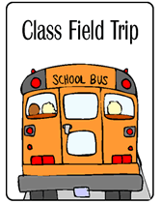

**FIELD TRIPS**

Field trips are encouraged for all grade levels. Each trip must be approved by the Principal, and each field trip must be educationally beneficial and directly related to a current area of study. Field trip request forms must be requested online for approval at least 2 weeks in advance. Transportation arrangements must conform to the Board of Education regulations. Permission slips are required for each participant and must be taken on the field trip. Please see the school secretary for forms. Dress appropriately for the activity. Field trip money must be turned in by noon each day on the appropriate form to the bookkeeper. A field trip form must be given to every child. An administrator must be consulted about any concerns regarding a student’s permission to attend a field trip. **No trips shall be planned the first and last month of the school year**.

**FIRE DRILL PROCEDURES**

In compliance with state law, this school will hold at least one fire drill each month. The first such drill each year will be announced as to the day and the time for the purpose of familiarizing students and teachers with exit routes and assembly areas. All subsequent drills will be executed without warning. At the sound of the fire alarm signal, all personnel will leave the building in an orderly manner by way of designated routes and exits. An exit plan is posted in each room of the school, and teachers are to make sure that all students are familiar with the route to be followed and the exit to be used by their class.

Each Teacher shall instruct his or her students in the proper behavior during a fire drill or emergency. These instructions must include at least the following topics:

• Walk, do not run

• Be quiet, do not talk in order that instructions may be heard over the speaker system

• Remain calm

• Do not crowd together, but remain a part of the class

• Listen and obey the Teacher’s instructions

The teacher is to remain in the classroom until all students have departed and then close the door as he/she leaves the classroom. Please bring your attendance book with you in order to take attendance during the fire drill. Complete the fire drill slip provided, and turn the slip in to the designated person for your location. (Exit door to Pre-K & Kindergarten hallway-Dunbar, 1st grade (back cafeteria door)-Livingston 2nd grade & SPED- Holmes, 3rd & 4th grades-Harrison, 5th grade –Glover) Lambert, Glover, and Bailey will cover areas for absentee personnel.

Since a fire or other emergency or disaster may block one or more exits, it will be the practice to block one or more exits during every fire drill except one. Teachers are to explain to their students the procedures they are to follow in such cases. This procedure will train students to remain calm and responsive to the Teacher’s instructions when an alternate route must be used. Students will be instructed to stop and remain calm and quiet when they encounter a blocked exit and wait for further instructions from their Teacher, who will lead them to a different exit. The new route selected by the teacher should not interfere with the exiting of other classes, but it should follow the last class using the new exit route.

**Fire Procedures and Maps are to be posted in a visible location in the classroom near the light switch.**

**GRADE CHAIRS FOR 2019-2020**

* **Pre-K**- Rosemary Rowe
* **Kindergarten**-Mrs. Katherine Green
* **1st  grade**- Ms. Claudia Crawford
* **2nd grade**- Mrs. Jolee Edwards
* **3rd grade**- Mrs. Elen Ellis
* **4th grade**-Mrs. Ashley Bailey
* **5th grade** - Ms. Tennille Jefferson
* **SPED**-Mrs. Sharon Murrell

**Grading**

Grades are to communicate effectively to parents and students; therefore the basis of their assignment should be clearly articulated. In assessing classroom work/performance, the focus should be placed on the student demonstrating that he or she has learned the written curriculum as defined by curriculum objectives and mastered the intended Standard.

Requirements:

* **At least 1 grade per week per subject entered into IC**
* **At least 9 grades per quarter per subject entered into IC**

**Hall Passes**

Students may not leave the classroom without a hall pass. Each student should have their own pass. The pass should indicate the teacher’s name and location that the student is reporting to.

**HOMEWORK**

The RCSS has a homework policy. Please review this policy individually and as a grade level. Please make sure that your homework is aligned with the appropriate grade level standards and with the appropriate instructional materials for your grade level and subject content. Daily homework is required, and time limits are established. Please follow policy as directed by district.

**HOSPITAL/HOMEBOUND INSTRUCTION**

The child who has a medically diagnosed, physical condition, which is non-communicable and restricts him/her to his/her home or to a hospital for a period of time and which will significantly interfere with his/her education, may be eligible for the service of a home/hospital instructor. In order for an individual to receive hospital or home instruction, a qualified physician must declare that the child is physically able to profit from education instruction. Other criteria must also be met. Special Education, the school, and the home will work together as a team to provide the student with the best possible instruction during the student’s absence from the regular classroom. Your hospital/ homebound POC is Dr. Yvette Wilson. Please email Dr. Wilson and Mrs. Lambert the name of the student who is hospitalized or will need homebound services. Please copy Mrs. Lambert on all correspondence relating to hospitalized students or students receiving homebound services.

**INSTRUCTIONAL SCHEDULES**

All teachers should submit their instructional schedules to the designated Instructional Coach for review on the 2nd Monday after the beginning of school. Teachers should collaborate with their grade levels and review the curriculum guide for the appropriate amount of time that should be spent on each content area. Instructional cards should include lunch, specials, recess, dismissal etc. Kindergarten and Reading teachers will submit their schedules to Mrs. Nadine Williams. 1st grade and math teachers will submit their schedules to Mrs. Dana Jackson. Once the IC approves the schedule; she will submit the schedule to Mrs. Bailey for the final approval. Mrs. Bailey will return schedules to teachers with her initials in the top right corner. Schedules may be posted once Mrs. Bailey’s initials are obtained.

**KEYS**

Each Teacher will be issued a key to his/her classroom and a badge to enter the front door of the school. Teachers are expected to exercise the utmost care and security of school keys and badge. Non-school personnel should not have access to your keys or badge. School keys should NEVER be duplicated. There is a $5.00 fee to replace a lost key and a fee to replace your badge. **Faculty and Staff must enter and exit the building through the front door only. Never admit anyone through any other entrance. This is for your safety as well as our students and our colleagues.**

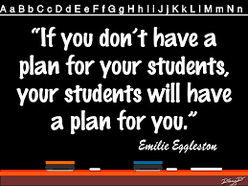**LESSON PLANS**

The success of the instructional program depends to a large extent on the planning that goes into the program. Much emphasis will be placed on the planning during the year. Always have extra (activities) planned for students who finish early. Library books, reference work, creative stories, and educational games are excellent examples. Be consistent and be clear about assignments.

We realize that children learn at different rates and lesson plans must be flexible so that they meet the teacher's needs as well as the students' needs. Two-day substitute emergency lesson plans must be on file in the front office to be easily accessible and used in the event your absence is unexpected. Having plans available in advance is a must. Current lesson plans must be placed at the visitor’s desk which is identified and mandatory in each classroom.

Lesson plans are expected to be submitted in Rubicon Atlas each Monday no later than 9:00 a.m. Plans should be submitted in two locations 1) Rubicon and 2) Lesson plan book located in the classroom at visitor’s desk. Each teacher should submit his/her individual plans.

**Staff Meeting Schedule**

|  |  |  |  |
| --- | --- | --- | --- |
| **Week of Month** | **Tuesday@ 3:30-4:00** | **Wednesday**  **Various Times** | **Thursday @3:30-4:30** |
| **1st** | **Data Team Meetings** | Content specific Collaborative Planning sessions will take place during your planning time in the data room. | **Faculty Meetings** |
| **2nd** | **Data Team Meetings** | **Literacy Team** |
| **3rd** | **Data Team Meetings** | **Culture and Climate Team** |
| **4th** | **Data Team Meetings** | **Math Instructional Team** |

**Staff Meetings/Thursday Meetings**

Thursdays are reserved for Professional Development and staff meetings (Thursday Meeting Rotation are provided above). These meetings will begin at 3:35 p.m. in room 406. **These meetings take precedence over other activities such as conferences and other personal appointments**. Permission must be obtained from the Principal before missing a Thursday meeting.

**Letters and Bulletins**

The principal must approve letters or other communications prepared by teachers or students, parents, and community partners.

**PBIS/DISCIPLINE**

**WGE School-wide Discipline Plan**

One of our SIP goals for this school year focuses on creating a positive culture at Wilkinson Gardens Elementary. The culture of our school is shaped and molded by the staff and students of Wilkinson Gardens. That means that we all have the ability to create the environment that we want to work in each day.  Please help to create a positive environment where we encourage instead of demean, motivate instead of discourage, problem-solve instead of complain, and where we are proactive instead of being reactive.  The learning environment in your classroom sets the tone for the behaviors students exhibit in the classroom. When students are involved in engaging, relevant, rigorous activities, **(TKES Indicators 2 and 3)** discipline issues are less likely to occur. A positive learning environment (**TKES-Indicator 7**) will yield a conducive classroom where students are able to excel. The tone we use with our students **(TKES-Indicator 10**) determines how our students will respond to us. Please know that we are here to support you in any way. Let’s work together as a team to follow the discipline procedures in place and help all of our students achieve success.

**Overview of School-wide Discipline Plan Documents**

**Conduct sheet/Teacher documentation form**-this document contains the student conduct sheet and the teacher documentation sheet that will follow students to all locations, to include specials and lunch. A copy of the teacher documentation log has been placed in your box. Please attach the documentation form to a clipboard.  Documentation should be stored in Class Dojo as well.

**Reflection Sheet**

Every teacher should have a buddy teacher. Students are to complete a refection sheet in the buddy teacher's classroom. Each teacher will need an isolated desk to use as a reflection chair in their class. K-2nd students should remain out of the classroom for a total of 15 minutes during reflecting time. 3rd-5th grade students should remain out of the classroom for a total of 30 minutes during reflecting time. Student should return with reflection sheet completed. The student will progress to parent communication if student refuses to complete the reflection.

**WGE PBIS Matrix (noted on next page)**

A poster of specific components of the matrix will be posted in every classroom and throughout the building.  It identifies what ROAR-ing behaviors looks like inside and outside of the classroom. Please review and discuss the matrix with your students daily for the first three weeks of school, and as needed thereafter.

**WGE Hierarchy of Discipline (noted on next page)**

Teachers are to utilize this document when submitting an online referral in Educator’s Handbook. Please file student's reflection sheet and conduct documentation. The administrator staff will call for the student. This is for the safety of the student and staff members. Administrators are not always present in the office, or available at the time that the student is sent to the office by the teacher. As a result, students are left in the front office unattended, or found roaming the hallways.  If needed for Tier 3 and 4, student maybe placed in a time out setting in another’s classroom until student is call by an administrator.

|  |  |
| --- | --- |
| R.O.A.R. | Classroom  **Voice Level 1** |
| R  **Respectful to others** | * Raise your hand * Take turns * Be kind to others * Keep hands, feet and objects to yourself |
| O  **Orderly at all times** | * Use classroom manners * Keep your area neat * Listen to your teacher * No running or horse playing |
| A  **Always Putting Safety First** | * Maintain self-control * Listen and follow directions * Ask before leaving your seat * Report any problems to the teacher |
| R  **Ready for success** | * Try your best * Participate * Learn and follow classroom expectations |

|  |  |  |  |  |
| --- | --- | --- | --- | --- |
| R.O.A.R. | Hallway  **Voice Level 0** | Media Center  **Voice Level 0-1** | Lunchroom  **Voice Level 0-1** | Restroom  **Voice Level 0-1** |
| R  **Respectful to others** | * Walk quietly in straight line * Be kind to others * Keep hands/feet to yourself * Go directly to your destination | * Work quietly, without disturbing others * Listen to and follow directions * Share resources | * Walk quietly in straight line * Use kinds words * Keep hands/feet to yourself * Keep food on your tray | * Wait your turn * Flush toilet after each use * Wash your hands after use * Use the soap dispenser and dryer responsibly |
| O  **Orderly at all times** | * Use hallway manners * Use hall pass * Walk on the right-hand side * Keep hands/feet off walls | * Use media center manners * Come in quietly * No food or drink * Return materials to proper place | * Use lunchroom manners * Enter & exit in an orderly manner * Stand in single file in lunch line * Keep table & floor area clean | * Use restroom manners * Flush toilet after each use * Wash your hands after use * Use the soap dispenser and dryer responsibly |
| A  **Always Putting Safety First**  R | * Maintain self-control * No running or horse playing * Report any problems to an adult | * Maintain self-control * Keep 2 feet and 4 legs on floor when seated * Walk at all times | * Maintain self-control * Stay in your seat * Walk at all times * Report any problems to an adult | * Maintain self-control * No horse playing * Report any problems to an adult |
| **Ready for success** | * Remain quiet * Keep hallway clean * Learn and follow hallway expectations | * Use quiet voices * Take good care of books, computers & equipment * Learn and follow media center expectations | * Use quiet voices * Listen to adults in charge * Learn and follow lunchroom expectations | ● Use quiet voices  ● Keep restroom clean  ● Learn and follow  restroom expectations |

|  |  |  |  |
| --- | --- | --- | --- |
| **Level One:**  **Incidental Violations**  (Non-referred/Non-recorded) | **Level Two:**  **Minor Violations**  (Non-referred/Recorded) | **Level Three:**  **Major Violation**  (Referred/Recorded) | **Level Four:**  **Illegal Violation**  (Referred/ Recorded) |
| - Running  - Loud Voices/Yelling  - Off-Task Behavior (classwork, sleeping, talking or playing during instruction, horse-playing)  - Name Calling (no profanity)  - Out of Seat  - Missing Homework  -theft (class tools)  - Other: | - Lying/Cheating  - ***Indirect*** Inappropriate Language or Gestures  - Inappropriate Dress  - Spitting  - Third Level Offense  -Name calling with profanity  -Insubordination (walking out of class)  -inappropriate internet use  - Other: | - Fighting/Physical Aggression  - Harassment/Bullying  - Overt Defiance  - Property Destruction/Misuse  - Theft (money, cell phones, secure items)  - Forgery  - Cyber bullying  - Skipping Class  - Third Level Two Offense  - Reference in conversation, writing or pictures to weapons or acts of violence  - Taking pictures/video without consent  - Other: | - Drug Use/Possession  - Weapon Use/Possession  - Truancy  - Arson  - Bomb Threat  - Extreme Property Damage or Vandalism  - Combustibles  - Assault/Threats  - Other: |
| **Level One:**  **Incidental Violations** | **Level Two:**  **Minor Violations** | **Level Three:**  **Major Violations** | **Level Four:**  **Illegal Violations** |
| **Teacher-Handled:** The Teacher addresses the behavior using classroom management strategies or loss of privileges.  -Duplicate actions should be documented three times before it is moved to the next level | **Teacher Handled:** The teacher addresses the behavior using logical consequences (apology of action, take a break, or loss of privilege, focus room).  Duplicate actions should be documented three times before it is moved to the next level | **Office Managed:** Page the office where the principal will address the behavior. | |
| **Document on your clipboard and Class DoJo**   1. **Verbal Warnings** 2. **Loss of Dojo point** 3. **Different Class/ Reflection** 4. **Parent Conference** 5. **Counselor referral** | **MIR:** Teacher will complete a MIR in Educator’s Handbook, print a copy for the student to take home, and file returned signed document.   1. **Verbal Warnings** 2. **Loss of Dojo point** 3. **Different Class/ Reflection** 4. **Parent Conference** 5. **Counselor referral** | **ODR:** Teacher will complete at ODR in Educator’s Handbook and call the office to escort the student (depending on severity). Administration will deliver the consequence according to the severity of the behavior and district policy. | |

**Parties**

Two formal parties are permissible during the school year **A Winter Holiday Party and End of the Year Party**. Parent volunteers may help plan the parties but the teacher is responsible for the actual party activities. Strict supervision and control must be maintained. Parties may not begin before 1:30 p.m. Other celebrations in the room, such as birthday parties or going away parties, for students will not be allowed. Parents may bring cupcakes during lunch in celebration of students’ birthday. Any other treats should be cleared through the Administration.

**Planning**

Planning periods are provided for all members during the designated schedule time. **Please use this time for the purpose intended.** This is an excellent time to cooperatively plan, analyze data, conduct RTI meetings, and participate in professional learning and/or parent conferences as they relate to the curriculum or general aspects of the total school. This is **not** a “free” time for non-duty related activities. Please refrain from attending to personal issues during this time, entertaining other staff members during this time, or any other activities that will hinder the fulfillment of the expectations of data reflection, planning, and instructional preparation.

**RECESS**

Recess is not a duty-free activity. Teachers must supervise students at all times while outside for recess. **Teachers should not take chairs outside during recess as this prohibits the process of active supervision.**

Pre-K and Kindergarten classes will utilize the Pre-K play-ground.

1st& 2nd grade will utilize the main larger playground.

3rd-5th Grade will utilize the grassy area located outside of the 3rd grade hallway side exit doors

**Report Cards/Progress Reports**

Report cards are sent home every nine weeks. The envelope must be signed and returned. The parent's signature is required so that the teacher will know that the parent has seen the card. It does not signify that the parent agrees with the marks on it. Please note the report card schedule located on the academic calendar. A conference must be schedule for every student who is not passing all subject areas. Documentation of conference must be collected and noted in IC contact log. Please retain a copy of the conference notice sent to parents.

Progress reports are sent home every 4 ½ weeks. The envelope must be signed and returned. The parent's signature is required so that the teacher will know that the parent has seen the card. It does not signify that the parent agrees with the marks on it. Please note the progress report schedule located on the academic calendar. A conference must be schedule for every student who is not passing all subject areas. Documentation of conference must be collected and noted in IC contact log. Please retain a copy of the conference notice sent to parents.

A conference must be schedule for every student who is not passing all subject areas. Documentation of conference must be collected and noted in IC contact log. Please retain a copy of the conference notice sent to parents.

**Timeline for Submitting Progress Report/Report Card Grades**

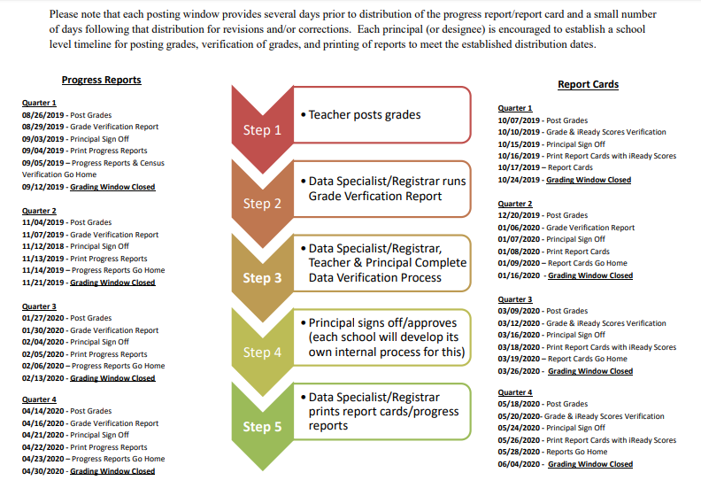

# Reports

Reports are necessary parts of teacher’s duties. Records should be kept to date and care exercised to assure accuracy and completeness. Please make it a habit to be prompt with all required reports. Tuesdays are designated to data analysis.

**RESPONSE TO INTERVENTION (RTI)**

The RTI was designed to provide classroom assistance to any student who is experiencing learning and/or behavior problems in school by providing support to the child's teacher and by serving as a consultant group. Please schedule all Tier 2 meeting with augmented teacher or IC noted below for your grade level. Augmented teachers will refer Tier 3 meetings to the Assistant Principal.

|  |  |
| --- | --- |
| Kindergarten | Mrs. Williams (IC) |
| 1st & 2nd Grade | Ms. Nell |
| 3rd Grade | Mrs. Jackson |
| 4th & 5th Grade | Ms. Lacy |

Teachers do not wait until the last nine weeks to refer a student for an RTI. Referrals should be done in a timely manner. Please remember to check student’s permanent record for previous RTI.

**Speakers (Resource)**

Many resource speakers visit our schools each year and complement the instruction provided by our teachers. However, not everyone who provides resource speaker services to the schools complement the instruction provided by the classroom teacher. Some are overzealous in presenting their personal views on a given topic, and some appear to have political or financial profit as a motive in appearing before a captive audience of students.

In an attempt to make the most effective use of resource speakers in our school the following guidelines will be followed:

The school principal must approve any resource person who is invited to speak to staff or students at a local school. A “Guest speaker” form is located in the front office.

A teacher who invites a resource person to speak to his/her students will provide the resource speaker with a general outline of the content to be covered (excerpts from course guides can serve this purpose).

Prior to the scheduled visit of the resource person, the local teacher prepares the students for the visitor’s presentation.

The local teacher who extends the invitation to a resource speaker is present at all times during the presentation by the local teacher. Local administrators are informed in advance and are encouraged to attend the presentation. In the event the visitor deals with a controversial topic, such as drug education, sex education, or values education, local school administrator is expected to be in attendance.

The teacher who extended the invitation to the visitor expects a follow–up discussion of the resource speaker’s presentation.

Resource speakers are not allowed to promote or sell commercial products to students. (For example, a resource speaker on the subject of dental care may encourage students to brush their teeth regularly but cannot promote or sell a specific brand of toothpaste or toothbrush).

**Surveys and Questionnaires**

The principal must first approve in writing any survey or questionnaire to be sent to a school to be filled in by any staff member or pupil.

Teachers Smoking

Smoking is prohibited in the building and on the campus at all times.

# 

# Our Teacher’s Lounge is a place that belongs to all of us. We must all cooperate and keep it a pleasant and attractive place. Please make sure you remove all old food from the refrigerator. You may eat in the lounge. The time spent in the lounge must be kept at a reasonable length. Students are not allowed in the lounge. Vending machines are available for adults only. Do not buy students drinks or snacks from the vending machines during school hours.



***Procedures:***

1. Close all classroom windows and doors.

2. Go to designated area as indicated on the map.

3. Students should be seated on the hall floor with their heads to corridor walls. Coats and jackets can be used to cover heads, arms, and legs, so as to reduce the number of injuries from flying missiles of glass and other debris.

4. There should be no talking during the tornado drill.

5. The signal for the tornado drill will be as follows:

***Announcement over the PA system:*** *“We are experiencing severe weather. Please take cover.”*

*Note: If severe weather occurs during dismissal time, students will be kept in the school.*

**Please post Tornado Drill Procedures and Map on the wall inside your classroom near the door.**

**PERMANENT RECORDS**

Permanent records are to remain in the vault unless the teacher is working on them. Permanent records must not be left in a classroom unless the teacher is with them. They are never to be taken home. All permanent records are to be secured in the vault at the end of each day. All entries must be made in permanent black ink. The Counselor will view all permanent records which are to be sent to another school. All permanent records are to be filled out properly. All permanent records must be signed out before they leave the vault and signed in when they are returned. The sign in/out form is with the Counselor. Paraprofessionals and students are not allowed access or handle permanent records.

**RECESS/PLAYGROUNDS**

Pre-K & kindergarten will use the small playground designed for their use. 1st -3rd will utilize the larger playground areas. 4th -5th will use the larger grassy area through side exit door on 3rd grade hallway. Recess times should be included on your instructional schedule that you turn in to the Instructional Coach for approval. Please be vigilant and supervise your students during recess. Recess should not exceed 15 minute increments. Teachers are allowed to schedule two recess segments within one day.

**STUDENT MAKE-UP WORK**

Students who miss assignments or tests due to non-attendance to school and/or class shall be allowed to make-up work. It is the responsibility of the parent and/or student to see the teacher, determine the work that must be made up, and turn in that work within one week.

**STUDENT MEDICATION**

Students may bring their own medication to school, marked clearly with their names and kept in the clinic. The medication must be carried to the clinic before school and picked up after school. Students who need to leave medication at school must have their parents complete and return an authorization form. No medication will be administered without proper documentation.

If a student is on prescribed medicine, a copy of the directions for giving the medicine should be given to the nurse in the clinic. The medicine must be left in the clinic and the student sent to the clinic to take it.

**STUDENT RECORDS**

All records must be kept strictly according to instructions, and must be done accurately. Student records and reports submitted to the office must be turned in alphabetically. All student records are strictly **CONFIDENTIAL. STUDENT RECORDS MAY BE DISCUSSED WITH THE STUDENT AND HIS/HER PARENT OR GUARDIAN ONLY.**

**SUPERVISION OF STUDENTS**

The teacher is responsible for the constant supervision of students. At no time during the school day should students be left unsupervised. Teachers are not to place students in the hallway unsupervised as a behavior consequence.

**SUPERVISION & SAFETY**

Teachers and/or other staff members shall practice good rules of safety. No one shall climb ladders, hang baskets from ceiling, stand in chairs, or any activity that could lead to accidents and/or injury that would jeopardize you, students, the school or the Board of Education in the loss of service in any way. It is the teacher’s responsibility to notify the parent when a child is ill or hurt, and also notifying the school nurse, front office and the Principal.

**BATHROOM PROCEDURES**

We are extremely fortunate to have bathrooms in our classrooms and don’t have to leave our classrooms and lose valuable instructional time to take our students to hall bathrooms. Please be reminded that the classroom bathrooms and the halls space that encase the bathrooms are NOT to be used as storage areas but as bathrooms for our students. The above actions are both safety and fire hazard infractions.

**WITHDRAWING STUDENTS**

**Teachers please notify the office as soon as you learn that a student is withdrawing from Wilkinson Gardens. We ask parents to give the office 24 hour notice, but sometimes the parent will tell the teacher and not the office. A withdrawal form must be filled out completely for any student withdrawing from school.** All information should be entered plus any additional information that you would like to add. Forms are available in the office. A copy of the report card and the report card envelope should be attached to the withdrawal form. Do not send any workbooks with the student to the new school.